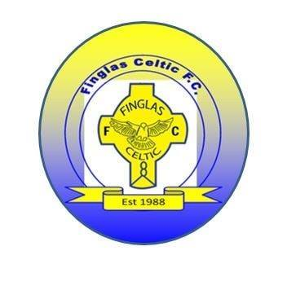  Dear Parents,  Finglas Celtic Football Club in partnership with the  FAI’s Paul Whelan have recently completed 6 week football skills course in St. Brigids Junior School, It was a great success and all the children really enjoyed it.  We at Finglas Celtic wish to invite the children to a  fun morning this Saturday 25th June in our Clubhouse  on Kilshane Road to meet Coach Ian who runs our junior football academy every Saturday morning.  Fun morning starts at 10am till 12  There’ll be hotdogs and candy floss on the day too  Hope to see you all there! | Dear Parents,  Finglas Celtic Football Club in partnership with the  FAI’s Paul Whelan have recently completed 6 week football skills course in St. Brigids Junior School, It was a great success and all the children really enjoyed it.  We at Finglas Celtic wish to invite the children to a  fun morning this Saturday 25th June in our Clubhouse  on Kilshane Road to meet Coach Ian who runs our junior football academy every Saturday morning.  Fun morning starts at 10am till 12  There’ll be hotdogs and candy floss on the day too  Hope to see you all there!

