Junior Infants 2021/2022
Information for Parents

Dear Parents/Guardians,

We would like to welcome you and your child to junior infants 2021 at St Brigid’s Infant School. We are really looking forward to welcoming you and your child into our school community! St Brigid’s is a Roman Catholic, mixed, infant school comprising of Early Start, junior infants, senior infants and first class.
This year we will have four small junior infant classes in our school. As well as the class teacher, there may be an SNA or support teacher working in your child’s classroom.
Here is some basic information you might need to know for your child’s first few days:

What does my child need to bring to school?
Books, Workbooks and Materials
The full cost of all books, workbooks and materials for Junior Infants is €60. The school will order and distribute everything once they have been paid for. You can pay on the open day or call to secretary Jackie’s window any day. The school office will be open the first week in July also.
The school will provide your child with all the stationery they need whilst in school (pencils/crayons/gluestick, pencil case etc). At home, you will need basic chunky pencil and crayons and a child’s scissors at to help your child with their homework.

School Bag
When choosing a school bag for your child, please ensure it is large enough to easily fit an A4-page sized folder inside (for homework) and their empty lunchbox. They will carry these things daily so they need to be able to put them into and take them out of their bags with ease.
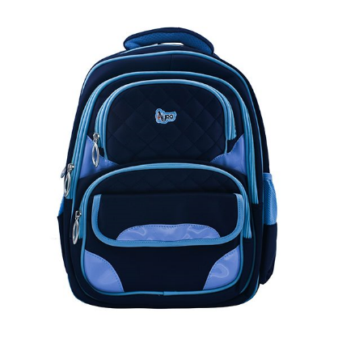

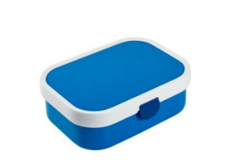

Uniform
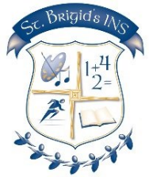
Our uniform is a navy-blue jumper/cardigan, trousers, white shirt and tie. The tracksuit, cardigan and trousers can be bought in any shop (e.g. Tesco, Dunnes, Marks and Spencers, Penneys etc.). The girls blue-checked pinafore dress can be purchased from McAloons in Finglas village. The school crest and ties are available from our school office to add to school jumpers/cardigans. Children will be asked to wear a navy-blue tracksuit and runners for their PE day. Teachers will inform you of this day during your child’s first few weeks at school. On cold days, leggings or track bottoms may be worn under uniforms.

Please help your child’s teacher by sending your child to school in shoes without laces. Please label all belongings – coats, jumpers, bags. Please teach your child to zip their jackets during the summer.

Lunches
Every child will be given a lunch menu. The lunches are FREE, funded by the Department of Social Protection and Employment Affairs. The lunches are prepared by Glanmore Foods under strict hygiene and Healthy Ireland nutrition guidelines. There are many options which cater for different tastes and dietary requirements. In September parents will be given a lunch form to fill out for their child. The menu can be changed as often as you want. Each child’s lunch is prepared and served in a sealed, labelled bag every day along with a bottle of water. Children are also offered milk and fruit every day. Water and milk are the only drinks allowed in our school. As part of our healthy eating policy, we ask that parents do not send in any additional food/snacks.

Your child will need to bring an empty lunch box each day in their bags. This is because they will bring home any uneaten food so you can see what they are eating at school. We also ask children to bring home their own rubbish for disposal at home. Please check/clean the lunch box daily.

Settling in
All children and ONE parent have been given an appointment to visit their new classroom on Wednesday 23 June. One parent is welcome to come in with their child to visit to the classroom, meet the teacher, enjoy playing with some games and get an activity pack for the summer. All adults are required to wear a mask on the school grounds and in the school building.
The children will see where they will line up every morning and their entrance door. In the new school year, children will line up on the smiley faces/footprints in the yard, say goodbye outside, walk in and sanitise their hands on entry. All children adapt so quickly to these morning routines.
The Early Start staff will be on hand on the first day of school to help their former Early Start children to settle into their new classes. The SNAs and SET teachers will also be on hand to make sure every child is settling in.
We will start with a short day and gradually work up to the full day during the month of September. School starts at 9.00 on Monday 30 August.

Communication
The class teachers will invite you to download the Class Dojo app so that you will be able to see photos of class activities and to give reminders about homework, PE etc. They may also post lessons from time to time.
It is easy to download and to use.
Our Home/School Liaison teacher Olwen is looking forward to getting to know all the new families. You can phone or Whatsapp her at 086 370 5773
We intend to return rewarding excellent attendance. The attendance habits formed in Junior Infants will stick for life, so please start as you mean to continue.
Any absence must be phoned into the office every morning. Do not message the teachers – they will not be looking at Class Dojo during the day because they will be working! If you have any concern or worry, please phone the office and we will arrange for a phone call or even a meeting to chat about the matter.
We send out regular newsletters and post all updates and photos of school activities on our website.
Urgent messages are sent out by Aladdin text.
We need three up-to-date emergency phone numbers for every child. Please save our school numbers on your phone.
Our Code of Behaviour, Anti-Bullying Policy and Acceptable Use policies are available to view on our website and we encourage you to read them carefully.

We will display pupil first names, teachers’ names and room numbers on our parents’ noticeboard, at the top of each class line and on the school website.

Thank you for entrusting us with the care and education of your child. We look forward to working in partnership with you so that your child will get off to a good start for a great education.

Summer homework!
Zips, opening and closing school bags, looking at the calendar on the fridge, saying goodbye knowing that you will be there to meet them at the end of the day.
Please don’t hesitate to contact us in the meantime if you have any other questions.
School phone: 01-8348770 HSCL phone: 086-3705773
School email: info@stbrigidsinfantschool.ie

