Junior Infants 2020/21
Information for Parents

Dear Parents/Guardians,

We would like to welcome you and your child to junior infants 2020/21 at St Brigid’s Infant School. We are really looking forward to meeting you and your child and welcoming them into our school! St Brigid’s is a Roman Catholic, mixed, infant school comprising of Early Start, junior infants, senior infants and first class. This year we will have 4 junior infant classes in our school. Here is some basic information you might need to know for your child’s first few days:

What does my child need to bring to school?
Books
We will let you know when you can begin to purchase your child’s new school books from our office and the cost of these. This will begin in September this year; your child will not need any books for their first couple of weeks.

Stationery
The school will provide your child with all the stationery they need whilst in school (pencils/crayons/glue etc). You will need basic pencil and crayons at home to help your child with their homework.

School Bag
When choosing a school bag for your child, please ensure it is large enough to easily fit an A4-page sized folder inside (for homework), their lunch, lunchbox and a drinks bottle. They will carry these things daily so they need to be able to put them into and take them out of their bags with ease.
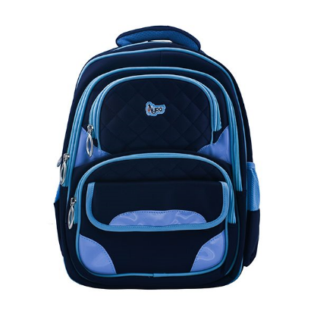

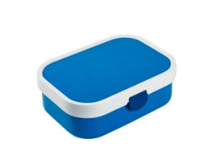

Uniform
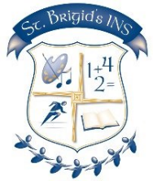
Our uniform is a navy-blue jumper/cardigan, trousers, white shirt and tie. The tracksuit, cardigan and trousers can be bought in any shop (e.g. Tesco, Dunnes, Marks and Spencers, Penneys etc.). The girls blue-checked pinafore dress can be purchased from McAloons in Finglas village. The school crest and ties are available from our school office to add to school jumpers/cardigans. Children will be asked to wear a navy-blue tracksuit and runners for their PE day. Teachers will inform you of this day during your child’s first few weeks at school.

Please help your child’s teacher by sending your child to school in shoes without laces. Please label all belongings – coats, jumpers, bags, water bottles.

Lunches
At St Brigid’s, all pupils are provided with lunch free of charge. The lunches are funded by the Department of Social Protection and Employment Affairs. The lunches are prepared by Glanmore Foods under strict hygiene and Healthy Ireland nutrition guidelines. There are many options which cater for different tastes and dietary requirements. In September parents will be given a lunch form to fill out for their child. The menu can be changed as often as you want. Each child’s lunch is prepared and served in a sealed bag every day. Children are also offered milk and fruit every day. Please send in a full bottle or beaker of water every day. Water and milk are the only drinks allowed in our school. As part of our healthy eating policy, we ask that parents do not send in any additional food/snacks.

Your child will need to bring an empty lunch box each day in their bags. This is because they will bring home any uneaten food so you can see what they are eating at school. We also ask children to bring home their own rubbish for disposal at home. Please check/clean the lunch box daily.

The staff at St Brigid’s Infant School are really excited to welcome your child to our school and junior infants in September!!

We will be in touch with all families in the coming weeks and we will provide further information about opening times, the settling-in timetable, payment for workbooks and materials, and of course their new teachers and classrooms.

Please don’t hesitate to contact us in the meantime if you have any other questions.
School phone: 01-8348770 HSCL phone: 086-3705773
School email: info@stbrigidsinfantschool.ie

